**Setting up Replica on China Replica Server**

1. Site->Utilities->File Server Administration-> File Server Management

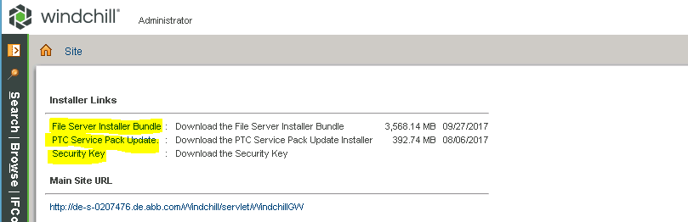

Download File Server Installer Bundle, PTC Service Pack Update and Security Key

1. Down the Windchill services on the replica server

Apache, Windchill, WindchillDS

Kill the java process related to Windchill

1. Extract the downloaded file.
2. Install PSI in CcsInstallerBundler

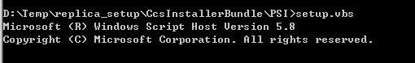

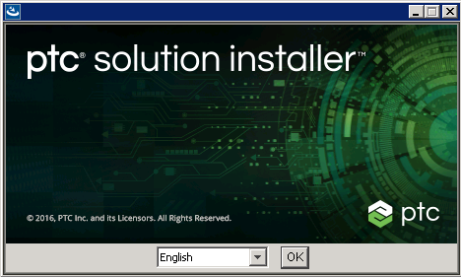

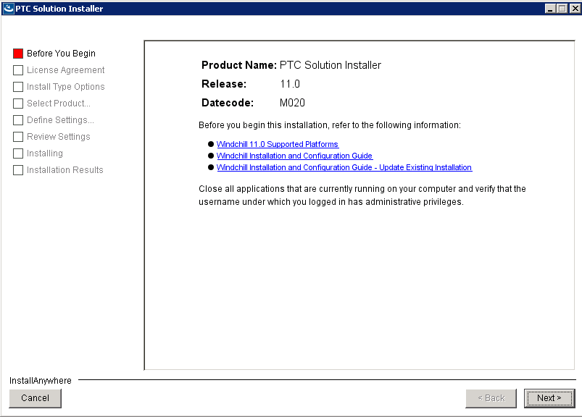

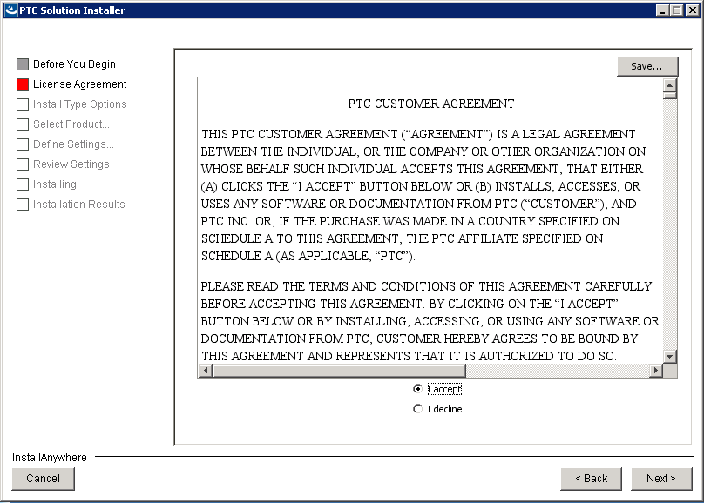

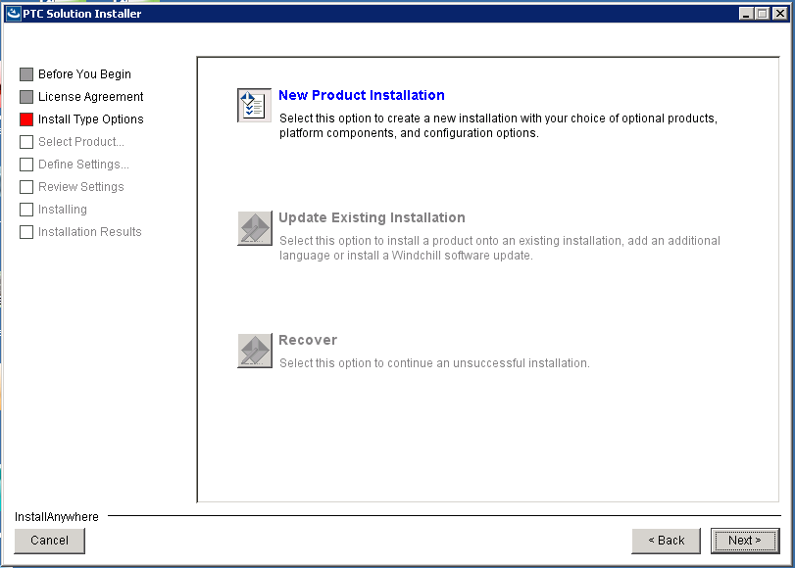

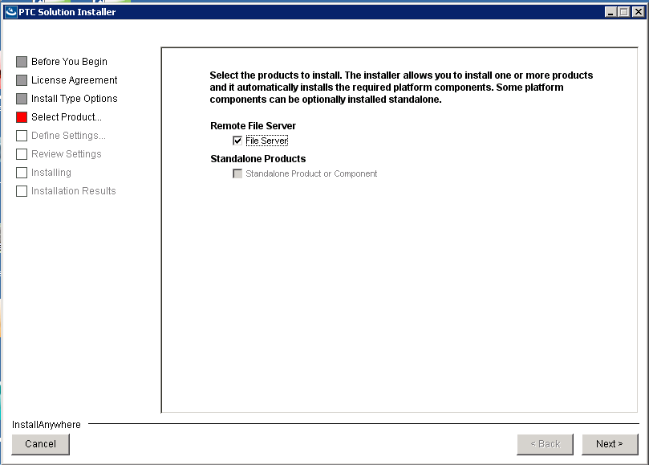

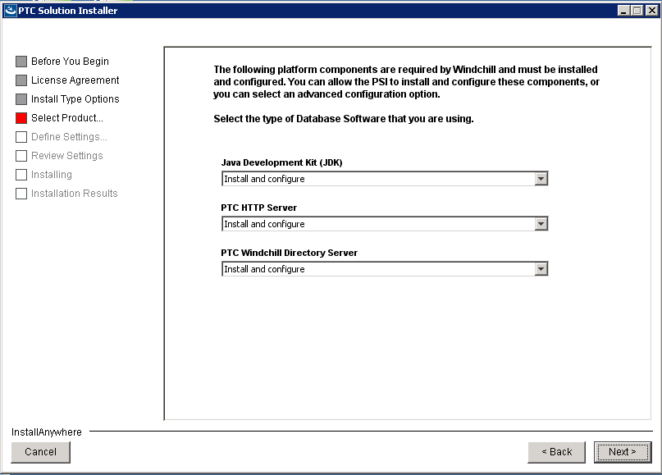

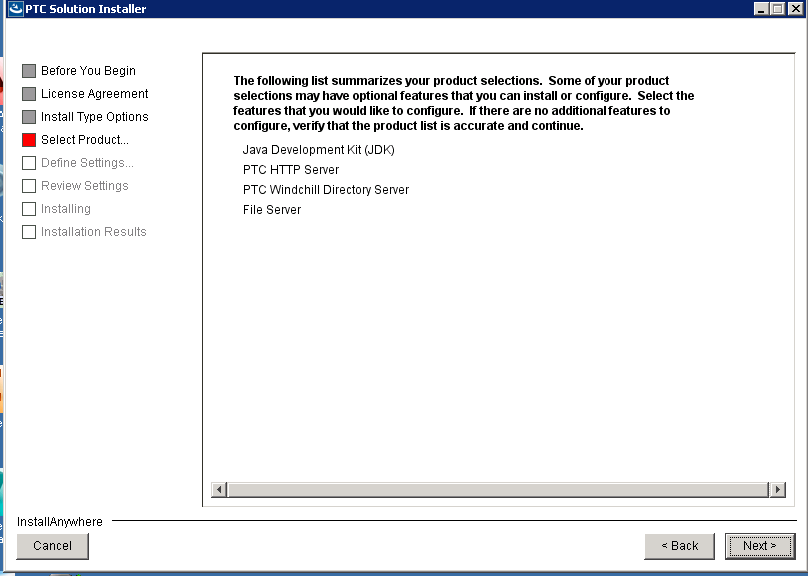

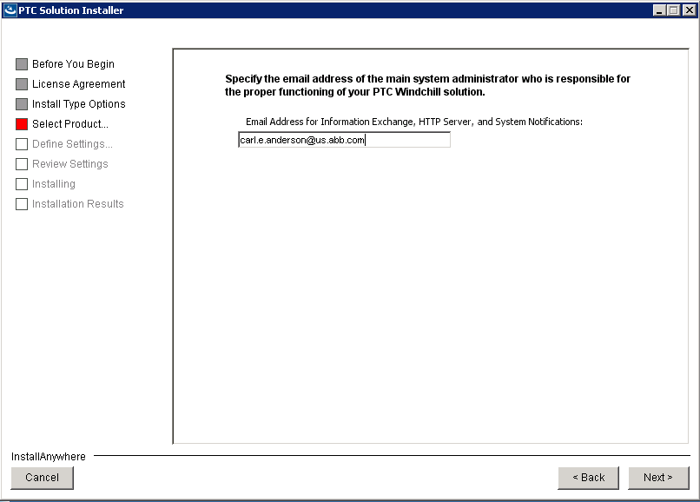

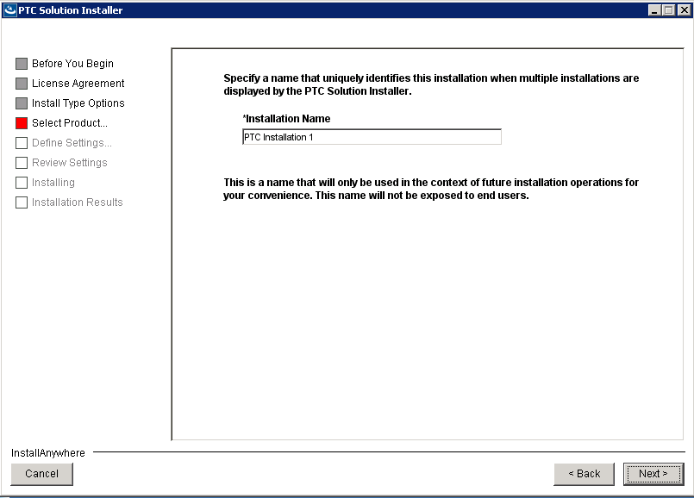

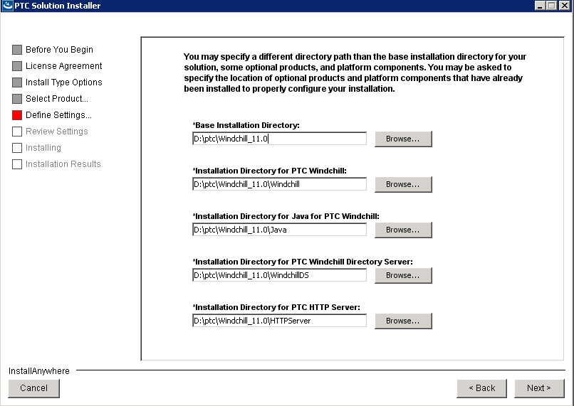

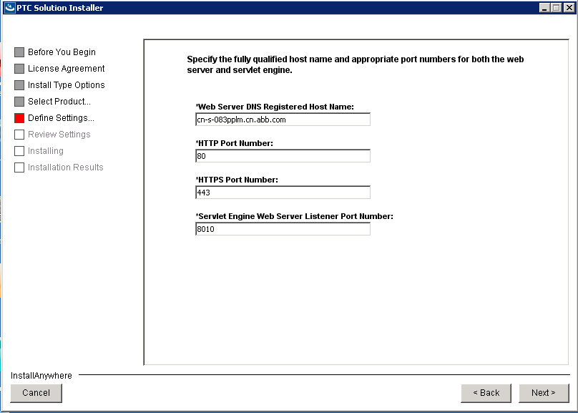

Shown error on HTTP Port Number: 80

It been changed to 8080

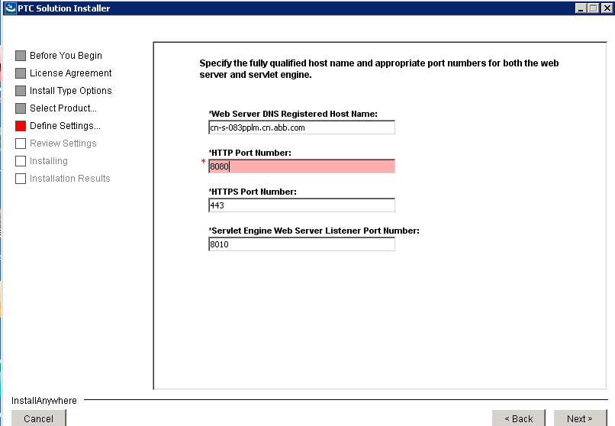

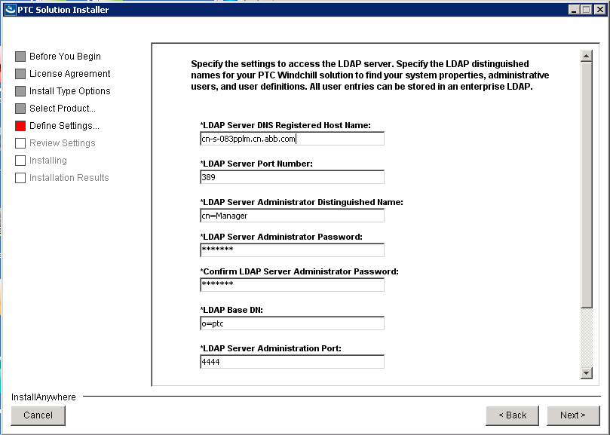

Password: manager

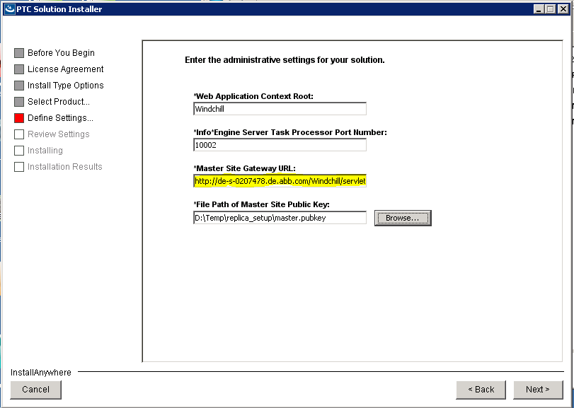

Mention the Production URL for Master Site Gateway Url:

http://de-s-0207478.de.abb.com/Windchill/servlet/WindchillGW

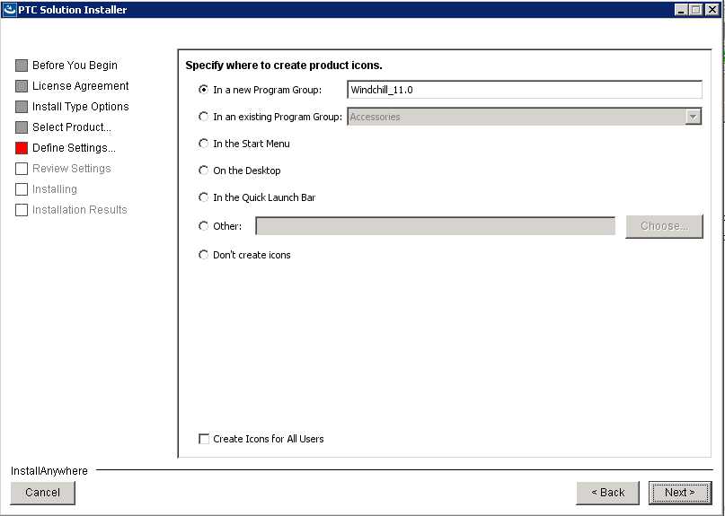

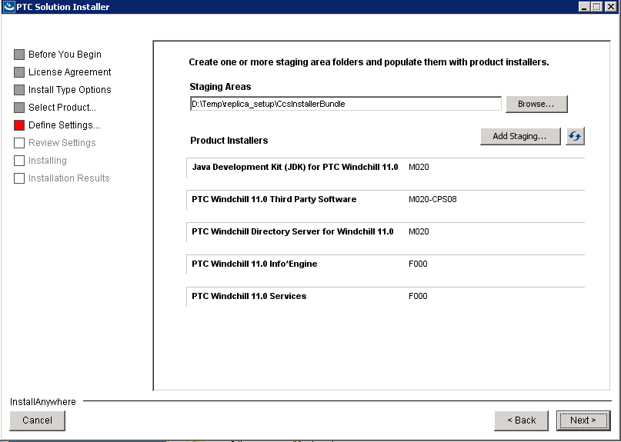

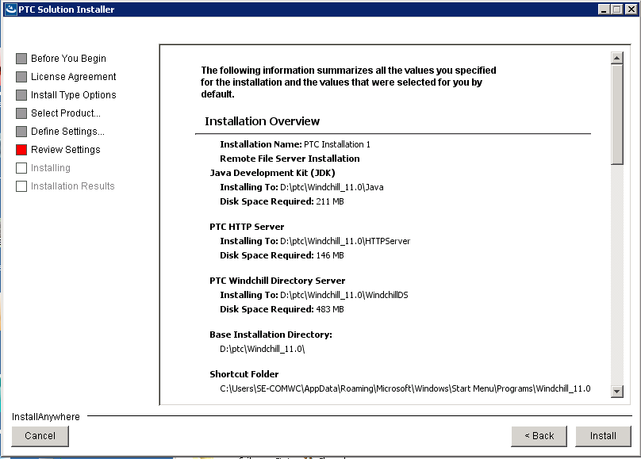



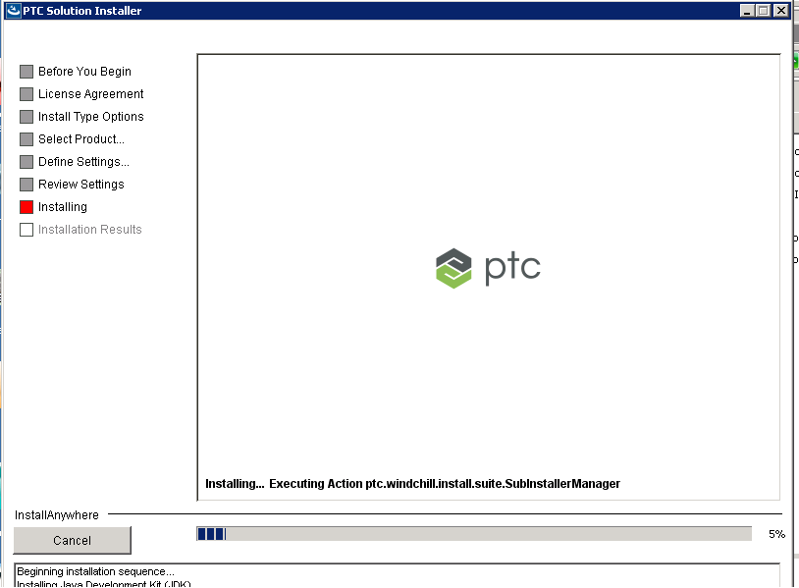

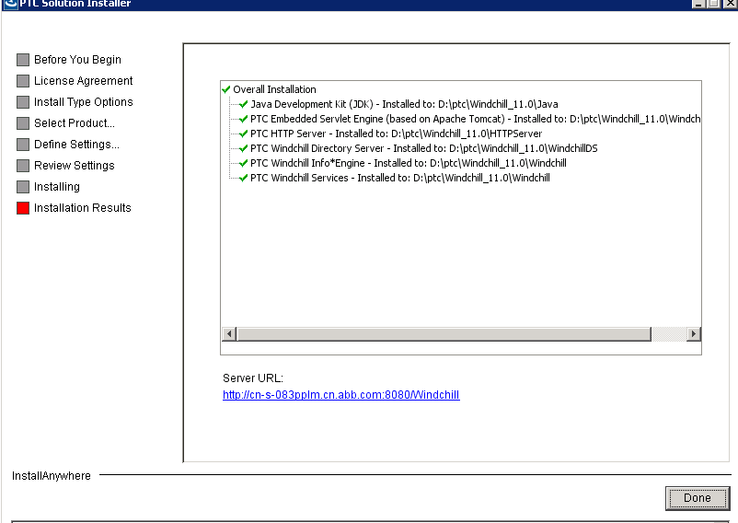

1. Copy CcsDus.zip to location D:\ptc\Windchill_11.0\Windchill\CCSTools\update
2. Run ant –f D:\ptc\Windchill_11.0\Windchill\bin\CCSTools\install_ccsdsu.xml command



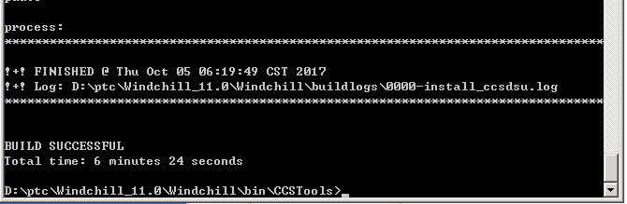

Check CssDsu.zip folder is been moved to location D:\ptc\Windchill_11.0\Windchill\CCSTools\completedUpdate

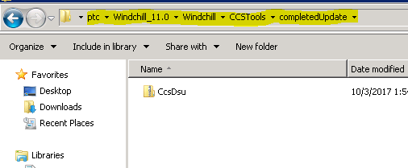

1. Start the Windchill Server





1. Stop the above started windchill.
2. Start the existing Windchill Services

Apache, WindchillDS, Windchill

Check on the Server Status Page of Replica Status.

